DOE ZOVEEL MOGELIJK IN WORKSPACE (NIET CAS LIBRARIES, behalve advanced ML proc steps
Begin met subset , werk je code daarop uit à deploy je code wanneer je klaar bent met code op volledige data set
Gebruik macro systime om te zien hoe lang procs duren, ....
Ctrl+h find & replace elke instantie v/e string!
“(Promote=yes) ” in eerste data statement à in memory geladen (of proc casutil)
Datalimiet om cas tabellen naar sas tabel à set.... (datalimit=all)
Als standaarddev 0 of min=max dan zijn da useless vars, mogen we weggooien!!!!
Als je zelfde wil doen met multiple vars à gebruik array:
Caslib _all_ assign à maakt cas libs & data visible
proc casutil outcaslib="casuser";
promote casdata="fullset";
quit; à savet set permanent naar cas lib

(promote=yes) gewoon na je data statement is beter dan die hele proc casutil

Bij unexpected errors, check es als je mss dingen tussen “” of ‘’ mss in hoofdletters moet zetten!

Scoring:
%let inputLib=Public;
%let inputTable =Table_Name;
%let modellib =Models;
%let modelTable =sas_model_table;
%let pubname =xxx; /* publish in model manager naar CAS, hier de published name*/
%let scorelib =casuser;
%let outTblName =scoreTable;
* Perform the job;
cas scoreJobSession;
proc cas;
table.droptable/
caslib="&scorelib."
name="&outTblName."
quiet=TRUE;
run;
loadactionset "modelPublishing";
modelPublishing.runModelLocal /
table={
caslib="&inputLib.",
name="&inputTable."
}
modelName="&pubname."
modelTable={
caslib="&modellib.",
name="&modelTable."
}
casout={
caslib="&scoreLib.",
name="&outTblName."
};
run;
table.promote/
caslib="&scorelib."
name="&outTblName.";
run;
quit;

enkel Var Selection voor NN en Regressies

output van een report verdergebruiken:
ods select nlevels;
ods output nlevels=nlevels;

proc freq data=public.jj_cork_070_valid nlevels;
run;

ods select all;

proc sql;
select TableVar into :nlevels separated by ' 'from work.nlevels where NNonMissLevels = 1;
run;
data public.cork_&numb._basic (promote=yes);
set public.jj_cork_0&numb._valid (datalimit=all);
timestamp_date=input(Timestamp, anydtdtm32.);
format timestamp_date datetime22.;
drop &nlevels;
run;

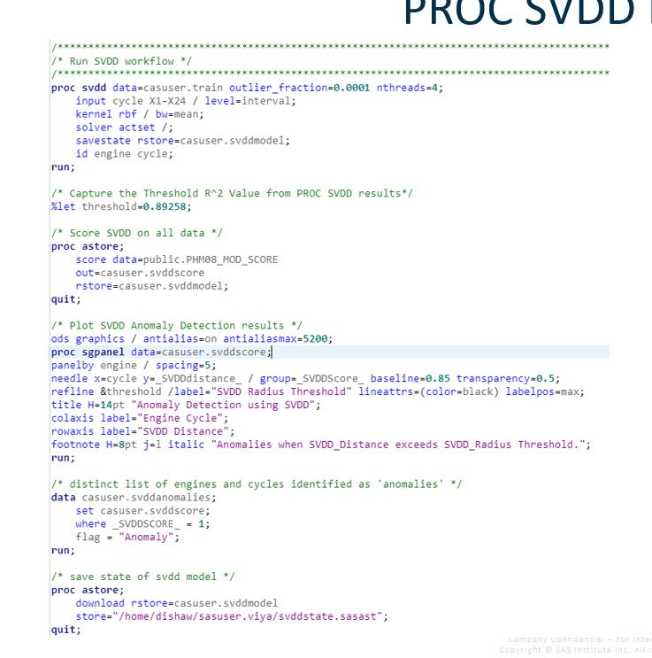

DATE or TIME ISSUES:
y=input(TimeStamp,anydtdtm.);
format y datetime20.;

APIS: filename result TEMP;

proc http
url="https://api.basisregisters.vlaanderen.be/v1/straatnamen"
method="GET"
out=result;
run;

libname opendata JSON fileref=result;
proc copy in=opendata out=work;run;

teksten inladen:
cas casauto terminate;
libname _all_ clear;
cas;

caslib mydocs path="/opt/data/vo/"
datasource=(srctype="path")
/*,encryptiondomain=string)*/
SUBDIRS;

caslib _all_ assign;

cas casauto sessopts=(caslib='mydocs');
/*
proc casutil;
list files nosubdirs;
quit;
*/

proc casutil;
list files subdir='aalst/';
quit;

proc casutil;
list files ;
quit;

proc cas;
table.loadTable / /*5*/
casOut={name="outTable",
replace=TRUE
}
caslib="mydocs"
importOptions={fileType="DOCUMENT",
fileExtList={"TXT", "XLS","PDF"},
recurse=TRUE,
tikaConv=TRUE,
tikaPath="/opt/sas/viya/home/SASFoundation/lib/docconvjars"
}
path="aalst";
run;

quit;

FEDSQL à session: CASAUTO

XML’s inlezen: ssemonthly /BENELUX/Data Management/XML/Read Content XMLs.sas

Coalesce(1, 2) à if 1 missing, replace w / 2 )

BEFORE ANY PROMOTION:
proc casutil incaslib="public";
droptable casdata="process_values_rename" quiet;
quit;

RELIABLE SORT:
data casuser.unsorted;
set &input_ds.;
if S44_ind = 1;
group = "A";
run;

data casuser.sort3 (partition=(group) orderby=(timestamp));
set casuser.unsorted ;
run;

